VOLUNTEER OPPORTUNITY PORTAL
@CREATIVITY THINK (9483175986/7019689991)

ABSTRACT:
The Volunteer Opportunity Portal is a web-based system designed to connect individuals with volunteering projects organized by NGOs, social groups, and community organizations. The platform enables volunteers to browse opportunities, apply, register, and track volunteer hours through an integrated dashboard. Administrators can manage projects, approve logged hours, and monitor overall activity using analytical reports. Built using Django and Django Rest Framework for backend functionality and React with redux and recharts for the frontend, the system provides a structured, scalable, and user-friendly environment to promote volunteering engagement and streamline opportunity management..

INTRODUCTION OF THE PROJECT:
Social organizations and NGOs often face challenges in managing volunteer registrations, tracking hours, and maintaining engagement records. Manual systems or scattered communication channels result in inefficiencies and limited visibility. The Volunteer Opportunity Portal provides a centralized digital platform that allows volunteers to easily explore opportunities, manage participation, and track progress. Administrators benefit from improved oversight, streamlined approval workflows, and well-organized analytics. The system enhances accountability and fosters increased participation by providing a transparent and structured volunteering environment..

PROJECT OBJECTIVES:

• Provide a centralized portal to view and apply for volunteer opportunities
• Allow volunteers to log, edit, and track their volunteering hours
• Enable administrators to manage projects and approve logged hours
• Offer dashboards for reports, analytics, and participation insights
• Simplify communication between volunteers and organizations
• Improve transparency and record-keeping of volunteering activities
• Streamline opportunity posting and participation tracking
• Promote social engagement through organized workflows

PROBLEM OF THE STATEMENT:
Most NGOs and volunteer-based organizations lack a well-organized digital system to manage opportunities, applications, and hour tracking. Manual processes lead to misplaced records, delayed approvals, and limited reporting capabilities. Volunteers find it difficult to track their involvement, while administrators struggle to maintain accurate participation logs. The Volunteer Opportunity Portal solves these challenges by providing a unified backend-driven system with secure APIs, transparent workflows, and structured dashboards tailored for both volunteers and administrators..

MOTIVATION OF THE PROJECT:
• To promote volunteering through easy access to opportunities
• To simplify registration and application management
• To maintain accurate volunteer hour records
• To help NGOs manage their programs efficiently
• To ensure transparency and accountability in participation tracking
• To provide meaningful analytics for performance measurement
• To encourage community involvement using technology

BLOCK DAIGRAM OF PROJECT:

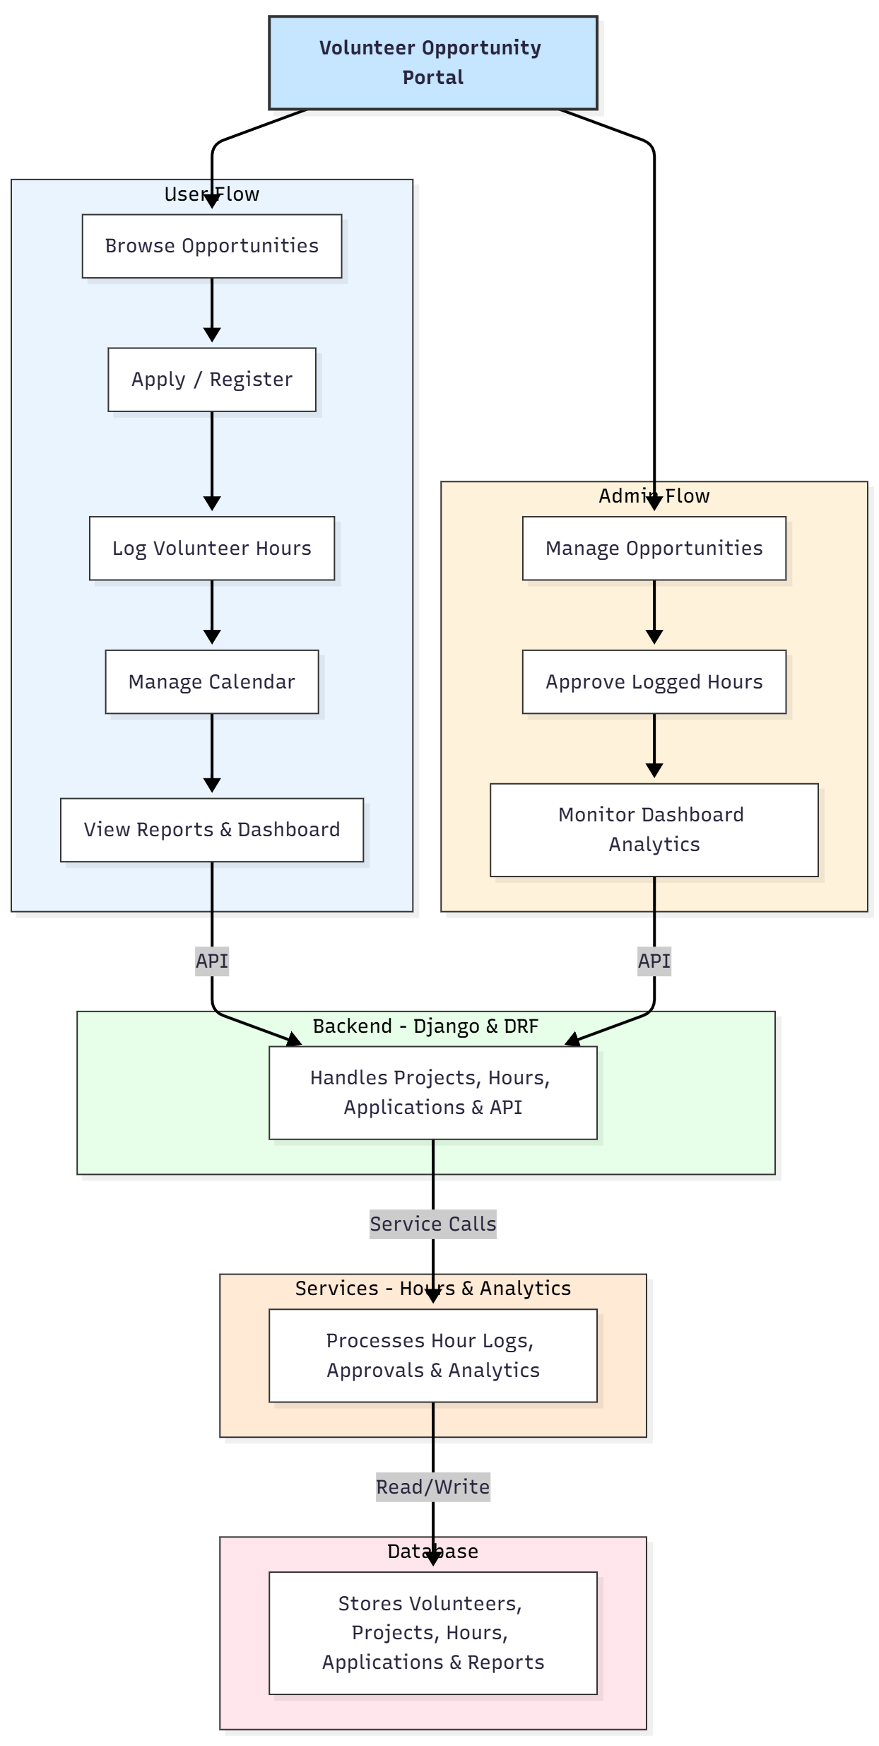

WORKING OF THE PROJECT:
The system begins when administrators add volunteer opportunities, including descriptions, dates, and requirements. Volunteers browse the listed opportunities and can apply or register directly. Once participation begins, volunteers can log their hours, track their progress, and manage events using an integrated calendar. Administrators review logged hours and approve or reject submissions. The backend manages project data, hour logs, user actions, and API communication, while the services module processes approvals and analytics. The database stores details of volunteers, projects, applications, hours, and reports, allowing real-time dashboard visualization and efficient record management..

SOFTWARE REQUIREMENT:
- Backend:
  - Python 3.x
  - Django
  - Django REST Framework
  - SQLite/PostgreSQL
- Frontend:
  - Node.js and npm
  - React.js
  - Axios
- Development Tools:
  - Visual Studio Code
  - Postman (for testing APIs)
  - Git/GitHub (for version control)
- Server/Deployment (Optional):
  - Gunicorn, Nginx, or Heroku/AWS for hosting

ADVANTAGES OF THE PROJECT:

• Simplifies opportunity discovery and registration
• Maintains accurate volunteer hour records
• Enhances communication between volunteers and organizations
• Provides dashboards for visual analytics
• Reduces manual paperwork and data entry errors
• Streamlines approval workflows for administrators
• Encourages community engagement through structured processes
• Suitable for NGOs, institutes, and large social groups

APPLICATIONS OF THE PROJECT:
• NGOs and social organizations
• Educational institutions
• Community volunteer groups
• Research and environmental clubs
• Student-led initiatives
• Large-scale event volunteer programs

REFERENCES:

- Django REST Framework Documentation — Django Software Foundation. Django Documentation. Available: https://docs.djangoproject.com/
- Django REST Framework. DRF Documentation. Available: https://www.django-rest-framework.org/
- React. React Official Documentation. Available: https://reactjs.org/docs/getting-started.html
- Redux. Redux Documentation. Available: https://redux.js.org/introduction/getting-started
- PostgreSQL Global Development Group. PostgreSQL Documentation. Available: https://www.postgresql.org/docs/
- MySQL. MySQL Reference Manual. Available: https://dev.mysql.com/doc/
- Git. Git Documentation. Available: https://git-scm.com/doc
- Node.js. Node.js Documentation. Available: https://nodejs.org/en/docs/
- Axios. Axios Documentation. Available: https://axios-http.com/docs/intro
- Socket.io Documentation – https://socket.io/docs/

